实验（3）—— 函数

学生姓名：黄伟杰 专业班级：计算机211
课程名称：面向对象程序设计 实验类型：综合

一 实验目的
练习C++函数。

二 实验环境
PC机 + Windows 10操作系统 + CodeBlocks 集成开发环境

三 实验内容
1,编写一个函数，找出在100-300范围中所有能被3整除又能被5整除的数。
#include <iostream>
using namespace std;
void solve() {
for (int i = 100; i <= 300; i ++)
if (!(i % 3) && !(i % 5)) cout << i << " ";
}
int main() {
solve();
return 0;
}
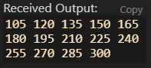
2,输入一个8位二进制数，将其转换为十进制数输出。
#include <iostream>
#include <cmath>
using namespace std;
const int LEN = 8;
void bintodec(char *str, int &num) {
int k = 0;
for (int i = LEN - 1; i >= 0; i --) {
num += (str[i] - '0') * pow(2, k);
k ++;
}
}
int main() {
int n1 = 0;
char bin1[10] = "11111111";
bintodec(bin1, n1);
printf("%s(B) -> %d(H)\n", bin1, n1);
int n2 = 0;
char bin2[10] = "11001011";
bintodec(bin2, n2);
printf("%s(B) -> %d(H)\n", bin2, n2);
int n3 = 0;
char bin3[10] = "11000111";
bintodec(bin3, n3);
printf("%s(B) -> %d(H)\n", bin3, n3);
return 0;
}
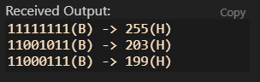
3,设计一个函数，求π。
#include <iostream>
using namespace std;
const int N = 1e8;
void solve() {
int sign = 1;
double PAI = 0;
for (int i = 1; i <= N; i += 2) {
PAI += (double)sign * 1.0 / i;
sign = -sign;
}
printf("%.7lf", 4.0 * PAI);
}
int main() {
solve();
return 0;
}
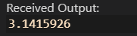
4,编写一个函数，用递归的方式求x的y次方。
#include <iostream>
using namespace std;
int quick_pow(int a, int k) {
int res = 1;
while (k) {
if (k & 1) res = (long long) res * a;
k >>= 1;
a = (long long) a * a;
}
return res;
}
int main() {
int x1 = 5, y1 = 4;
printf("%d^%d = %d\n", x1, y1, quick_pow(x1, y1));
int x2 = 15, y2 = 3;
printf("%d^%d = %d\n", x2, y2, quick_pow(x2, y2));
int x3 = 32, y3 = 5;
printf("%d^%d = %d\n", x3, y3, quick_pow(x3, y3));
return 0;
}
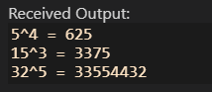
5,编写一个函数，解决汉诺塔问题。
// 原题见洛谷 P1760 通天之汉诺塔
// 默认三根圆柱 其中一根圆柱放置着自上而下大小逐步递增的圆盘
#include <iostream>
using namespace std;
const int N = 1e3 + 10;
int hanoi(int n) {
int dp[N];
dp[1] = 1;
for (int i = 2; i <= n; i ++) dp[i] = dp[i - 1] * 2 + 1;
return dp[n];
}
int main() {
int n1 = 3;
printf("当圆柱上的圆盘个数是%d时，至少需%d步才能完成汉诺塔问题要求。\n", n1, hanoi(n1));
int n2 = 10;
printf("当圆柱上的圆盘个数是%d时，至少需%d步才能完成汉诺塔问题要求。\n", n2, hanoi(n2));
int n3 = 15;
printf("当圆柱上的圆盘个数是%d时，至少需%d步才能完成汉诺塔问题要求。\n", n3, hanoi(n3));
return 0;
}
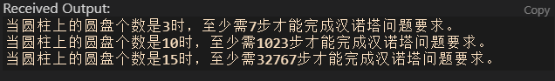
6,编写一个函数，能交换两个整型数组。
#include <iostream>
#include <algorithm>
using namespace std;
void swaparr(int arr1[], int arr2[], int len) {
for (int i = 0; i < len; i ++) swap(arr1[i], arr2[i]);
}
int main() {
int n1 = 10;
int arr1_1[10] = {4, 9, 86, 5, 13, 29, 8, 4, 65, 1};
int arr1_2[10] = {16, 54, 5, 649, 84, 55, 1, 53, 13, 15};
printf("arr1: "); for (int i = 0; i < n1; i ++) cout << arr1_1[i] << " ";
printf("\narr2: "); for (int i = 0; i < n1; i ++) cout << arr1_2[i] << " "; puts("");
swaparr(arr1_1, arr1_2, n1);
printf("arr1: "); for (int i = 0; i < n1; i ++) cout << arr1_1[i] << " ";
printf("\narr2: "); for (int i = 0; i < n1; i ++) cout << arr1_2[i] << " "; puts("\n");
int n2 = 10;
int arr2_1[10] = {78, 45, 61, 32, 79, 8, 4, 65, 13, 2};
int arr2_2[10] = {1, 2, 36, 5, 1, 23, 54, 61, 32, 56};
printf("arr1: "); for (int i = 0; i < n2; i ++) cout << arr2_1[i] << " ";
printf("\narr2: "); for (int i = 0; i < n2; i ++) cout << arr2_2[i] << " "; puts("\n");
swaparr(arr2_1, arr2_2, n2);
printf("arr1: "); for (int i = 0; i < n2; i ++) cout << arr2_1[i] << " ";
printf("\narr2: "); for (int i = 0; i < n2; i ++) cout << arr2_2[i] << " "; puts("\n");
int n3 = 10;
int arr3_1[10] = {9, 7, 46, 5, 113, 26, 58, 4, 65, 1};
int arr3_2[10] = {13, 24, 98, 7, 987, 4, 65, 3, 2, 1};
printf("arr1: "); for (int i = 0; i < n3; i ++) cout << arr3_1[i] << " ";
printf("\narr2: "); for (int i = 0; i < n3; i ++) cout << arr3_2[i] << " "; puts("");
swaparr(arr3_1, arr3_2, n3);
printf("arr1: "); for (int i = 0; i < n3; i ++) cout << arr3_1[i] << " ";
printf("\narr2: "); for (int i = 0; i < n3; i ++) cout << arr3_2[i] << " "; puts("");
return 0;
}
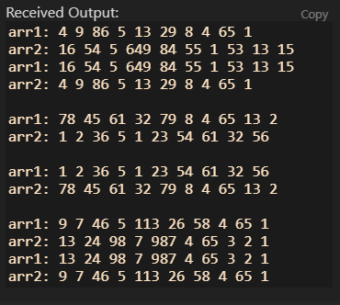
7,实现一个函数，能统计一段文字中，某个单词的出现次数。
#include <iostream>
#include <unordered_map>
using namespace std;
unordered_map<string, int> mp;
int check(char c) {
if (c >= 'A' && c <= 'Z') return 1;
else if (c >= 'a' && c <= 'z') return 2;
return 0;
}
void Cal(char *str) {
mp.clear();
int k = 0;
char tmp[20];
for (int i = 0; *(str + i); i ++) {
int tp = check(str[i]);
if (tp == 1) tmp[k ++] = str[i] - 'A' + 'a';
else if (tp == 2) tmp[k ++] = str[i];
else {
tmp[k] = '\0';
k = 0;
mp[tmp] ++;
}
}
}
int main() {
char str1[110] = {"Hello world,hello world hello world hello!"};
Cal(str1);
for (auto t : mp)
cout << t.first << " " << t.second << endl;
puts("");
char str2[110] = {"I love cpp,cpp is the best programming language!"};
Cal(str2);
for (auto t : mp)
cout << t.first << " " << t.second << endl;
puts("");
char str3[110] = {"i hate python,i hate python,i hate python!"};
Cal(str3);
for (auto t : mp)
cout << t.first << " " << t.second << endl;
puts("");
return 0;
}
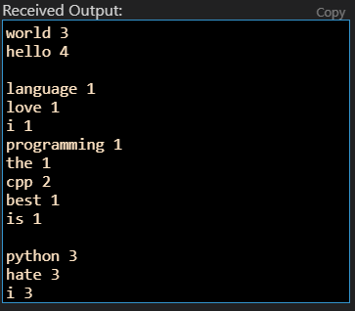
8,有以下表示学生的结构体：
struct student
{
int num; //学号
char name[20]; //姓名
char gender; //性别
int age; //年龄
char addr[30]; //寝室
};
请定义2个结构体变量，初始化后通过swap()函数交换2个结构体变量的信息。
#include <iostream>
#include <cstring>
using namespace std;
typedef struct student {
int num; //学号
char name[20]; //姓名
char gender; //性别
int age; //年龄
char addr[30]; //寝室
}stu;
void struct_swap(stu &x, stu &y) {
int tn;
char ts1[20], ts2, ts3[30];
tn = x.num; x.num = y.num; y.num = tn;
strcpy(ts1, x.name); strcpy(x.name, y.name); strcpy(y.name, ts1);
ts2 = x.gender; x.gender = y.gender; y.gender = ts2;
tn = x.age; x.age = y.age; y.age = tn;
strcpy(ts3, x.addr); strcpy(x.addr, y.addr); strcpy(y.addr, ts3);
}
int main() {
stu x1 = {101, "Mike", '1', 18, "201"};
stu y1 = {102, "Tony", '0', 18, "202"};
printf("x->%d %s %c %d %s\n", x1.num, x1.name, x1.gender, x1.age, x1.addr);
printf("y->%d %s %c %d %s\n", y1.num, y1.name, y1.gender, y1.age, y1.addr);
struct_swap(x1, y1);
printf("x->%d %s %c %d %s\n", x1.num, x1.name, x1.gender, x1.age, x1.addr);
printf("y->%d %s %c %d %s\n", y1.num, y1.name, y1.gender, y1.age, y1.addr);
puts("");
stu x2 = {103, "CPP", '1', 20, "203"};
stu y2 = {104, "PY", '0', 20, "204"};
printf("x->%d %s %c %d %s\n", x2.num, x2.name, x2.gender, x2.age, x2.addr);
printf("y->%d %s %c %d %s\n", y2.num, y2.name, y2.gender, y2.age, y2.addr);
struct_swap(x2, y2);
printf("x->%d %s %c %d %s\n", x2.num, x2.name, x2.gender, x2.age, x2.addr);
printf("y->%d %s %c %d %s\n", y2.num, y2.name, y2.gender, y2.age, y2.addr);
puts("");
stu x3 = {105, "iii", '1', 50, "205"};
stu y3 = {106, "yyy", '0', 50, "206"};
printf("x->%d %s %c %d %s\n", x3.num, x3.name, x3.gender, x3.age, x3.addr);
printf("y->%d %s %c %d %s\n", y3.num, y3.name, y3.gender, y3.age, y3.addr);
struct_swap(x3, y3);
printf("x->%d %s %c %d %s\n", x3.num, x3.name, x3.gender, x3.age, x3.addr);
printf("y->%d %s %c %d %s\n", y3.num, y3.name, y3.gender, y3.age, y3.addr);
return 0;
}
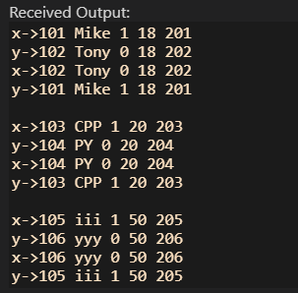
四 实验小结
巩固了C++的函数。

